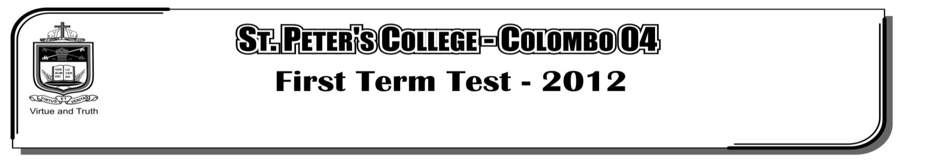

**THIRD TERM EXAMINATION - 2021**

**GRADE 10 – Western Music**

**02 Hours**

**Part - II**

**Answer question 01 which is compulsory and 04 other selecting *two* from each part A and B.**

01. Compulsory :- Questions are based on the following music ‘Musette’

**(12 Marks)**

1. The composer of the given extract is J. S. Bach. Write the name of the composer where it should appear in the music.

2. Name a contemporary composer of J. S. Bach.

3. To which nationality does this composer belong to?

4. Name two compositions by J. S. Bach.

5. Give the year of birth of J. S. Bach.

6. The above music is to be played ‘Fast’ write appropriate tempo mark at the correct place.

7. The music piece is in Ternary form, Mark the sections with bar numbers.

Principal theme Bar __________ to Bar __________ Episode Bar __________ to Bar __________ Principal theme Bar __________ to Bar __________

8. The key signature of the piece is D major. Name the modulation (change of key) in bars 16 and 17 __________

9. Explain the time signature __________

10. Write the corresponding compound time signature of time.

11. The bars 1 to 4 is repeated in the piece several times. In which bars is it repeated? __________

12. Name 2 types of articulation marks shown in the piece?

**Section – A**

Select 02 questions

02. (a). B flat major scale ascending with key signature use the given rhythm .

**(03 Marks)**

|  |
| --- |
|  |
|  |
|  |
|  |

(b). D melodic minor scale descending use accidentals use F clef. **(03 Marks)**

|  |
| --- |
|  |
|  |
|  |
|  |

(c). Using the correct key signatures write the following triads as semibreves. **(04 Marks)**

|  |  |  |  |
| --- | --- | --- | --- |
|  |  |  |  |
|  |  |  |  |
|  |  |  |  |
| root position  subdominant  triad C major | second inversion  Tonic triad  G major  first inversion  dominant triad  B flat major |  | root position  mediant triad  A major |

(d). Write a note above the given note to form the required interval. **(02 Marks)**

perfect 5th above

minor 3rd above

|  |  |
| --- | --- |
|  |  |
|  |  |
|  |  |
|  |  |

03. (a). Write these cadences in SATB (fourparts) with the correct key signature. **(08 Marks)**

|  |  |
| --- | --- |
|  |  |
|  |  |
|  |  |
|  |  |
|  |  |
|  |  |
|  |  |
|  |  |
|  |  |

Imperfect in E minor

Perfect in F major

(b). Describe Ternary form and Air with variation form with examples. **(04 Marks)**

04. (a). Name an instrument associated with each of the following. **(08 Marks)**

Valve -

Bridge -

Damper -

Reed -

Plectrum -

Pick -

Slide -

Pedals -

(b). Name 04 sections of action of the piano. **(04 Marks)**

1.

2.

3.

4.

**Section – B**

05. (a). Match column **A** in to **B** **(05 Marks)**

**A**

i. The strings of an acoustic guitar are tuned to,

ii. Highest in pitch in the orchestra,

iii. It is held between the chin and the shoulder,

iv. Large bronze disc struck with a beater,

v. The largest and deepest sounding Brass instrument,

**B**

Tuba , Gong , EADGBE , Piccolo , Violin

(b). Name two composers of musicals. **(02 Marks)**

1. 2.

(c). Name 4 titles of musicals. **(04 Marks)**

1. 2.

3. 4.

(d). Write a difference between opera and musicals. **(01 Marks)**

06. (a). Explain Nurthi and Nadagam briefly, giving examples. **(06 Marks)**

(b). Mark  in each box as the first example given. **(06 Marks)**

|  |  |  |  |  |  |  |  |
| --- | --- | --- | --- | --- | --- | --- | --- |
|  | Solo  Singers  Aria | Orchestra | Scenary | Actedout | Biblical  Text | Recitative | Costumes |
| Opera |  |  |  |  |  |  |  |
| Oratorio |  |  |  |  |  |  |  |

07. (a). Name the form indicated by the given. **(08 Marks)**

|  |  |
| --- | --- |
| Examples | Form |
| a). Harmonious blacksmith  b). Lavenders blue  c). Drink to me only  d). Country gardens  e). AshGrove  f). FurElize  g). Troutquintet  h). Soldiers march |  |

(b). Divide the following Italian terms into the categories below.

Andante, Leggerio , Crescendo , Staccato , Cantabile , Adagio , Mezzo piano , Alla Marcia , Legato **(04 Marks)**

|  |  |
| --- | --- |
| **Category** | **Italian term** |
| Tempo |  |
| Dynamics |  |
| Mood |  |
| Articulation |  |

